An Efficient CNN-Based Framework for Automated Blood Cell Classification in Hematological Disease Diagnosis

Ravinder Singh
Chitkara University Institute of Engineering and Technology
Chitkara University,
Rajpura-140401, Punjab, India
sainibanwait22@gmail.com
Rishav Nath Kaura
Chitkara University Institute of Engineering and Technology
Chitkara University,
Rajpura-140401, Punjab, India
rishavkaura49@gmail.com
Rajat Chauhan
Chitkara University Institute of Engineering and Technology
Chitkara University,
Rajpura-140401, Punjab, India
rajatgurjar1570@gmail.com

Abstract—Proper classification of blood cells is crucial in the efficient diagnosis and treatment of hematologic disorders, especially leukemia. Traditionally, blood smear images could be analyzed manually, which is time consuming, subjective, and susceptible to human error; thus, there is a need to have automated and effective diagnostic support systems. The paper describes a convolutional neural network (CNN)-based model that is used to classify the images of blood cells into four different categories (Benign, Malignant Pre-B, Malignant Pro-B, and Malignant Early Pre-B). A dataset of 3,242 microscopic blood cell images (from Kaggle) was used to train and test the proposed model. The experimental findings indicate that the model had a total classification accuracy of 98.76% with high values of precision, recall, and F1-score among all classes. The model was particularly effective in distinguishing the malignant categories of cells, which implies it can extract the discriminative morphological information of the blood smear images. The training and validation accuracies, loss analysis, and classification metrics, and the evaluation of the confusion matrix, were further used to validate the strength and generalization capability of the suggested CNN. The results indicate that CNN-based automated classification may offer a rapid, precise, and consistent method of blood cell analysis. Thus, the framework suggested can be used to aid in the diagnosis of hematological diseases by enhancing the efficiency of diagnostic tests and minimizing the reliance on manual microscopic analyses.
Keywords—CNN, blood cell classification, Artificial Intelligence, deep learning, convolutional neural networks

Introduction
The classification of blood cells is a basic activity in hematology and medical diagnoses, because it assists in identifying and monitoring various disorders involving the blood, such as anemia, lymphoma, and leukemia. Many blood cells are broadly classified into three major types, namely red blood cells (RBCs), white blood cells (WBCs), and platelets. RBCs make sure the oxygen is delivered, platelets aid in blood clotting, and WBCs are in the middle of the immune system activity. WBCs are particularly significant among them in cancer-related blood cell analysis since the abnormal morphology of these cells can be a sign of hematologic malignancies. The leukocytes are further classified into neutrophils, lymphocytes, monocytes, eosinophils, and basophils, which are referred to as white blood cells. Both types have a particular immune role and can be abnormal in case of pathological conditions. The lymphocytes are especially important in the diagnosis of leukemia since some of the leukemia types are a result of the maldevelopment of lymphoid cells. This study categorized blood cell images in four groups, namely Benign, Malignant Pre-B, Malignant Pro-B, and Malignant Early Pre-B. The classes are clinically significant, benign, and malignant cell patterns that should be properly identified to be properly diagnosed, planned, and prognosed. Proper classification of blood cells is crucial due to the fact that the early and accurate diagnosis of malignant cells may have a direct impact on patient outcomes. It helps clinicians to differentiate between benign and malignant diseases, to choose an appropriate treatment plan, and to monitor the development of the disease. Nevertheless, classical microscopic analysis by hand is both time-intensive and subjective, and can be easily influenced by human factors, particularly when large volumes of blood smear images are involved. Convolutional neural networks (CNNs) have emerged as powerful tools for medical image analysis due to their ability to automatically learn spatial and morphological features from images. CNNs are able to detect finer visual variations between blood cell types and offer automated and high-throughput classification with greater consistency and efficiency. Thus, the purpose of the study is to design a CNN-based model that can classify blood cells in four classes accurately, and the idea is to enhance the speed of diagnosis, its reliability, and clinical decision support in the diagnosis of hematological diseases.

Literature Review
Accurate, rapid, and reproducible interpretation of microscopic images is essential in the field of automated blood cell classification, which is an important research direction in computer-aided hematological diagnosis. Traditional manual examination of blood smear images is very much dependent on expert observation, and it is subjective, prone to fatigue, and prone to inter-observer variations. In recent years, with the development of convolutional neural networks, transfer learning, transformer, and segmentation-based learning, the ability of automated systems to recognize benign and malignant blood cell patterns has been significantly improved. Cheuque et al. [1] presented an efficient multi-level CNN for WBC classification and showed that the hierarchical CNN-based feature extraction can enhance the classification performance by learning the discriminative morphology of the cells at various abstraction levels. In the same way, Davamani et al. [2] proposed an adaptive blood cell segmentation and hybrid learning-based classification strategy, which adopted segmentation and meta-heuristic optimization to improve the feature representation of cells. These studies show that, in addition to the architecture of the classifier, effective preprocessing, segmentation, and feature selection strategies are essential for accurate blood cell classification. Shahzad et al. [3] also conducted a systematic review, which revealed that blood cell image segmentation and classification are still a challenging problem because of various variations in staining, illumination, cell overlap, and morphological similarity among different cell types. These restrictions are especially relevant in the fields of leukemia and blood cancer classification, where subtle visual differences between the various types of blood cancers can significantly impact the interpretation of the diagnosis. In this context, Li et al. [4] proposed domain-invariant representation learning with the Segment Anything Model, demonstrating that foundation-model-based segmentation and representation learning can assist in mitigating domain shift among blood cell datasets. This direction is important due to the fact that images from real-world hematological applications are acquired under varying conditions using different imaging devices and laboratories. Transfer learning has also been a focus of recent studies for blood cell cancer diagnosis. Bhattacherjee et al. [5] used ResNet50 with transfer learning for blood cell cancer classification, which proved the utility of the pretrained convolutional features in the context of blood cell image analysis. Jain and Kaushik [6] investigated the advanced CNN techniques for enhancing the accuracy in blood cell cancer classification, which further strengthens the significance of CNN-based methods in automated malignancy detection. The models based on EfficientNet have also been highlighted due to their proper balance of depth, width, and resolution. Kaur et al. [7] used EfficientNetB3 to classify blood cells for cancer detection, and Kaushik and Sharma [8] used EfficientNetB3 for automated detection of leukemia. These studies have shown that transfer learning models have the ability to offer robust feature extraction capability, particularly when the medical dataset is limited. Besides blood cancer classification, deep learning techniques have been successfully used for other microscopic blood-smear diagnosis tasks. In Kaushik and Sharma [9] proposed the use of EfficientNetB3 for automated malaria detection, and another CNN-based malaria detection framework was proposed in [10]. While these works are not for leukemia, but for malaria, they are still relevant as they show the usefulness of deep learning in microscopic cell image analysis, and they help to validate the general applicability of CNN-based diagnostic systems. Recently, transformer-based models have opened up new possibilities for blood cell classification, which are able to capture long-range contextual relationships. Jain et al. [11] presented the potential of attention-based and self-supervised feature learning with a Swin Transformer and Momentum Contrast learning for leukemia diagnostics, and Üzen and Fırat [12] proposed a hybrid multipath Swin Transformer and ConvMixer architecture for white blood cell classification, while Chen et al. [13] investigated shifted-window vision transformers for blood cell classification. Moreover, Alshehri et al. [14] have presented a hybrid involution and convolution neural network for leukemic and white blood cell classification, which suggests that the generation of a dynamic kernel can enhance the adaptability of local features. Outside of hematology, cross-domain medical imaging studies like OsteoFusionFormer [15] demonstrate that the fusion of local and global features with transformers can enhance diagnostic representation learning. In summary, the literature reviewed demonstrates that CNNs, transfer learning models, segmentation-based approaches, and transformer architectures have all played a vital role in automated blood cell analysis. But many of the advanced models demand lots of computational resources, large datasets, or complicated training methods. Thus, the current CNN-based approach is still significant because it is designed to offer a reliable, less complex, and practical solution to the problem of automated blood cell classification.

METHODOLOGY
The data utilized in the current work is the open-source dataset of the Kaggle platform, which uses the ALL Challenge dataset of ISBI 2019 (C-NMC 2019), initially released by The Cancer Imaging Archive by Mourya et al. [16]. This data was chosen due to its direct relevance to automated blood cell classification and diagnostic analysis related to leukemia. It has 3,242 microscopic blood cell images, which are grouped into four clinically relevant categories: Benign, Malignant Pre-B, Malignant Pro-B, and Malignant Early Pre-B, as shown in Fig. 1. The distribution by class is 512 Benign images, 955 Malignant Pre-B images, 796 Malignant Pro-B images, and 979 Malignant Early Pre-B images. The images are labeled with each being identified with the cell category to which it belongs, which allows the proposed convolutional neural network model to be supervised. Despite a slight variation in the classes within the dataset, it has an adequate representation of benign and malignant blood cell patterns to build an automated classification framework. Using this publicly available dataset contributes to reproducibility and enables the comparison with the current hematological diagnostic studies with deep learning. In this paper, the dataset is the main input in training, validation, and testing of the proposed CNN model with the objective of enhancing the accuracy of automated blood cell classification to diagnose a hematological disease.
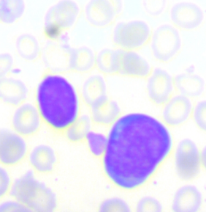  (a) Benign | 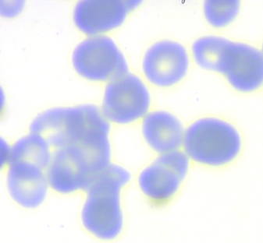  (b) Malignant Pre-B
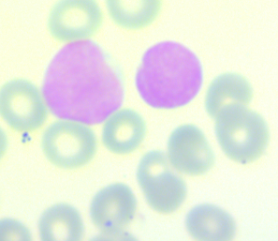  (c) Malignant Pro-B | 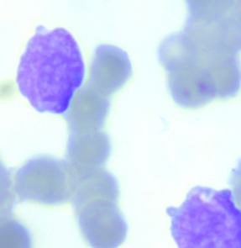  (d) Malignant Early Pre-B
Fig. 1. Representative microscopic blood cell images from the C-NMC 2019 dataset showing Benign, Malignant Pre-B, Malignant Pro-B, and Malignant Early Pre-B classes
The proposed methodology will include four significant procedures of automated blood cell classification with a convolutional neural network (CNN). The data of 3,242 microscopic blood cell images is initially prepared using resizing, normalization, and image enhancement. The pictures are classified into four subgroups: Benign, Malignant Pre-B, Malignant Pro-B, and Malignant Early Pre-B. These preprocessing tasks are a way to guarantee a standard image size, enhance visual quality, minimize input variability, and enable the CNN to learn meaningful morphological features during training. As illustrated in Fig. 2, the entire workflow will start with the acquisition and preprocessing of data, then proceed to the CNN-based feature extraction, model training, performance analysis, and ultimate classification output. This workflow gives a visible end-to-end view of the proposed system to demonstrate how raw microscopic blood cell images can be converted to clinically meaningful predictions of the cell class.
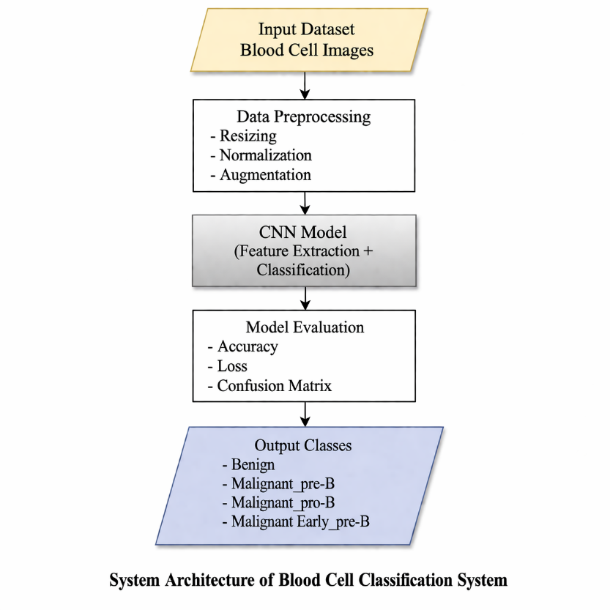
Fig. 2. Overall workflow of the proposed CNN-based blood cell classification framework
The CNN model is developed and trained on the processed dataset in the second step. The architecture is comprised of convolutional layers to extract local features, including cell boundaries, texture, shape, and internal structural patterns. Max-pooling layers reduce the number of computations and spatial dimensions, and batch normalization layers enhance the stability and convergence of training. They have dropout layers to reduce overfitting and enhance generalization. As the network is developed, subsequent convolutional layers are able to learn increasingly abstract and class-specific features of blood cell images. The flattened feature map is then subjected to fully connected dense layers to make final decisions. The output layer is based on the SoftMax activation function that will classify every image in one of the four target classes. The proposed CNN architecture is based on a progressive feature-learning approach, as in Fig. 3, the low-level visual patterns are first learned in the first layers, and the high-level discriminative features are learned in the successive levels. This stratified structure allows the model to be more effective in differentiating visually similar malignant subtypes.
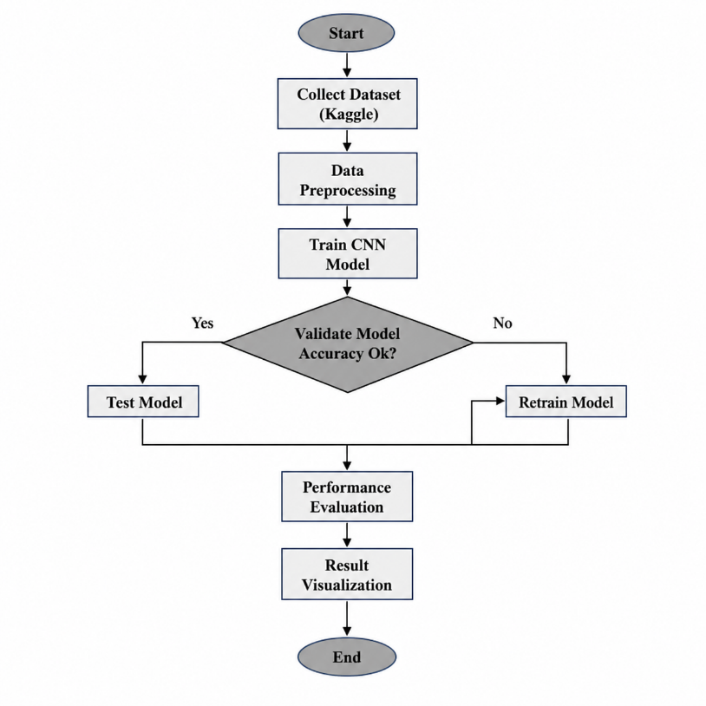
Fig. 3. Architecture of the proposed convolutional neural network for four-class blood cell classification
The third step is to test the trained CNN model with test data to achieve the accuracy, precision, recall, and F1-score. Lastly, the classification metrics, training and validation curves, and confusion matrix are evaluated to determine how healthy, stable, and capable the model is to generalize to unknown blood cell images.

RESULTS
The developed CNN model showed good precision in the classification of blood cell images into four groups: Benign, Malignant Pre-B, Malignant Pro-B, and Malignant Early Pre-B. The overall accuracy of the model was 98.76, which means that it was effective in the classification of benign and malignant patterns of blood cells. The classification report demonstrated the high value of precision, recall, and F1-score among all classes, and the malignant categories were especially strong. Moreover, the macro and weighted average scores were more than 97%, which validated balanced performance on classification. The confusion matrix also indicated that there was not much misclassification of the four classes, which justified the reliability of the proposed model. These findings reveal that the CNN-based model is capable of classifying blood cells precisely and consistently and could be an effective instrument in the process of automated hematology disease detection.

Classification Report Analysis
The blood cell categorization model exhibits impressive performance across all four classes—Benign, Malignant_Pre-B, Malignant_Pro-B, and Malignant_ Early_Pre-B. Especially for Malignant_Pre-B at 0.99, the model exhibits excellent accuracy, therefore reflecting appropriate expectations of this class. Malignant_Pre-B also has a strong recall; 0.97 shows how effectively most relevant events were identified. Benign at 0.96 shows an excellent mix between precision and recall; the F1-scores are strong: Malignant_Pre-B, Malignant_Pro-B, and Malignant_ Early_Pre-B score 0.98. The general accuracy of 0.98 proves that 98% of the forecasts match. The macro and weighted averages highlight still another consistent and balanced performance of the strategy. These measures show the model's dependability and efficiency in precisely categorizing blood cell pictures, therefore rendering it a useful tool for diagnosis, as shown in Fig. 4.
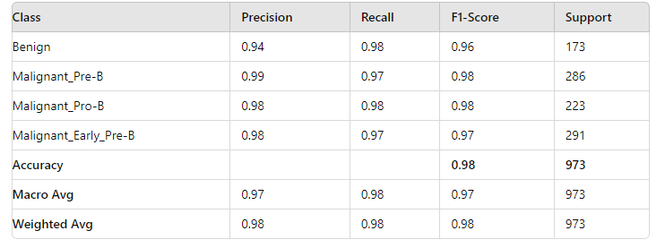
Fig. 4. Classification report of the proposed CNN model showing precision, recall, F1-score, and support for each blood cell class

Training and Validation Loss Analysis
Evaluation of a convolutional neural network (CNN) model depends critically on the study of training and validation loss. Within the framework of the blood cell type classification challenge, the observed training and validation loss offer information on the generalizing ability of the model toward unprocessed data. With precision, recall, and F1-scores across all classes showing great performance, the model clearly attained a high accuracy of 98.76%, according to the comprehensive performance measures. This great degree of accuracy implies that the model has minimized the loss function during training rather successfully. More especially, the constantly excellent precision and recall values show that the model's forecasts are dependable and accurate. Whereas the validation loss shows the model's performance on a different validation dataset, the training loss shows its error on the training data. Usually, a lower training loss than a validation loss indicates that the model is learning from the training data rather effectively, although if the validation loss is much higher, the model may be overfitting. In this sense, the lack of significant differences between training and validation losses suggests that the model generalizes effectively to fresh data, therefore strengthening the CNN architecture used. Based on the minimal and consistent losses across both training and validation phases, the study generally emphasizes that the model has been well-optimized and achieves a balance between generalization and training performance. As shown in Fig.5.
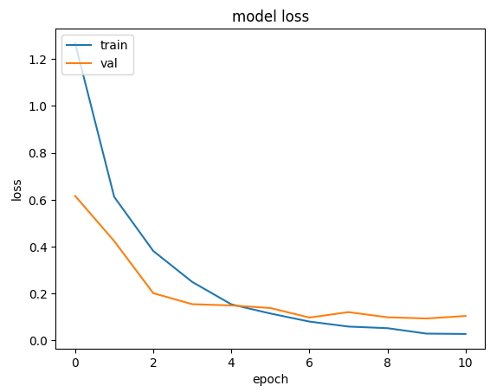

Fig. 5. Training and validation loss curves of the proposed CNN model across epochs

Training And Validation Accuracy Analysis
Based on training and validation accuracy studies, the CNN model showed a general accuracy of 98.76% in blood cell classification. This excellent accuracy suggests that the model quite remarkably separates the four classes: benign, malignant pre-b, malignant pro-b, and malignant early pre-b. The training accuracy indicates how effectively the model has learned from the training data; the validation accuracy indicates how well the model might be extended to unknown data. Training and validation accuracy points almost line up to indicate a well-calibrated model free from overfitting. This consistency in performance over both datasets indicates that the model can consistently categorize fresh blood cell pictures, therefore guaranteeing both strong learning and efficient generalization. Such a result emphasizes the effectiveness of the approach in practical settings where constant and accurate classification is crucial. As shown in Fig. 6.
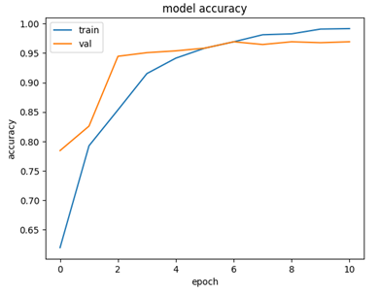
Fig. 6. Training and validation accuracy curves of the proposed CNN model across epochs

Confusion Matrix Analysis
Benign, Malignant Pre-B, Malignant Pro-B, Malignant Early Years Pre-B's blood cell categorization model confusion matrix provides a complete overview of the model's performance on these four classes. The model’s performance on these classes, as shown in the confusion matrix, indicates exceptional accuracy in differentiating these various classes with astonishing accuracy and recall on each of these classes. Thus, with a precision of 0.99 and a recall of 0.97, the model particularly indicates great performance in identifying Malignant_Pre-B cells, therefore showing minimum misclassification for this class. The exceptional accuracy and recall values for Malignant_Pro-B and Malignant_early pre-B cells also indicate the reliability of the model. Though this model indicates only considerably lower scores, the Benign class also indicates great efficiency categorization ability with a precision of 0.94 and a recall of 0.98. The confusion matrix provides a general idea of the efficiency and accuracy of the model, thus validating its robustness in real-world blood cell classification, even if there is no great level of confusion between classes, as shown in Fig. 7.
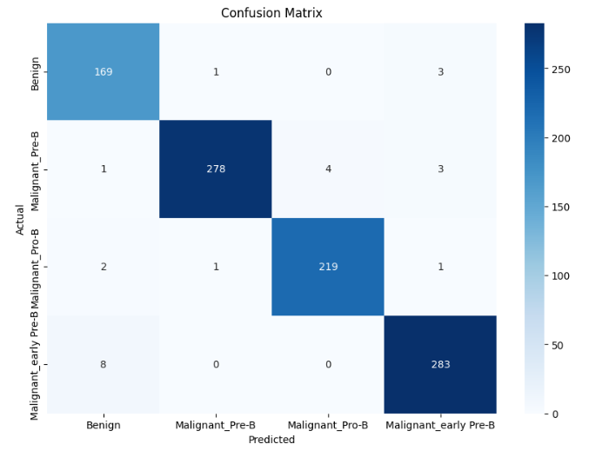

Fig. 7. Confusion matrix of the proposed CNN model for Benign and malignant blood cell classification

Conclusion
The paper describes an effective CNN-based model to classify blood cells (especially Benign, Malignant Pre-B, Malignant Pro-B, and Malignant Early Pre-B) automatically. This model had a total accuracy of 98.76 with a high level of precision, recall, and F1-score for all the classes. The results of the training and validation point to the fact that the model is highly optimized and can effectively generalize to unseen information. Additionally, the confusion matrix analysis indicates that there is little misclassification, particularly in malignant classes, which confirms the model as reliable in the diagnosis of hematological diseases. The proposed CNN-based method is a quicker, more reliable, and precise method of classifying blood cells in comparison to the manual microscopic detection method. To enhance the model in future work, it is possible to use bigger and more varied datasets retrieved from various sources of clinical information. The models of transfer learning that can be examined to further improve the classification performance include ResNet, EfficientNet, and transformer-based architectures. Further data augmentation methods may be used to enhance noise, image quality, and class-imbalance robustness. In addition, explainable AI can be incorporated to emphasize clinically significant areas of the blood cell images, enhancing clinical interpretability. The suggested framework can be further developed into a real-time clinical decision support system to provide practical diagnosis in hematology.

REFERENCES
- C. Cheuque, M. Querales, R. León, R. Salas, and R. Torres, “An Efficient Multi-Level Convolutional Neural Network Approach for White Blood Cells Classification,” Diagnostics, vol. 12, no. 2, p. 248, Jan. 2022, doi: 10.3390/diagnostics12020248.
- K. Anita Davamani, C. R. Rene Robin, D. Doreen Robin, and L. Jani Anbarasi, “Adaptive blood cell segmentation and hybrid Learning-based blood cell classification: A Meta-heuristic-based model,” Biomedical Signal Processing and Control, vol. 75, p. 103570, Feb. 2022, doi: 10.1016/j.bspc.2022.103570.
- M. Shahzad et al., “Blood cell image segmentation and classification: a systematic review,” PeerJ Computer Science, vol. 10, no. 1, p. e1813, Feb. 2024, doi: 10.7717/peerj-cs.1813.
- Y. Li et al., “Domain-invariant representation learning via SAM for blood cell classification,” Pattern Recognition, vol. 170, p. 112000, Feb. 2026, doi: 10.1016/j.patcog.2025.112000.
- A. Bhattacherjee, V. Gupta, M. Kaur, S. Mehta, E. Jain, and P. Kaushik, “Blood Cell Cancer Classification Using ResNet50 and Transfer Learning: Enhancing Diagnostic Accuracy in Hematology,” Dec. 2024, pp. 1–6. doi: 10.1109/dasa63652.2024.10836321.
- E. Jain and P. Kaushik, “Enhancing Precision in Blood Cell Cancer Classification: Cutting-Edge CNN Techniques for Improved Accuracy,” Nov. 2024, pp. 330–334. doi: 10.1109/cybercom63683.2024.10803127.
- P. Kaur, A. S. Kalra, A. Bhattacherjee, K. Khushboo, R. Brar, and P. Kaushik, “Blood Cell Classification for Cancer Detection Using EfficientNetB3,” Sep. 2025, pp. 1–5. doi: 10.1109/icicis65613.2025.11371070.
- P. Kaushik and P. Sharma, “Automated Leukemia Detection Using EfficientNetB3: A Robust Deep Learning Approach for Accurate and Efficient Diagnosis,” Mar. 2025, pp. 1127–1131. doi: 10.1109/autocom64127.2025.10957570.
- P. Kaushik and P. Sharma, “Deep Learning for Automated Malaria Detection: A EfficientNetB3-Based Analysis of Microscopic Cell Images,” Dec. 2024, pp. 322–326. doi: 10.1109/icscna63714.2024.10864268.
- Kaushik, P., & Sharma, P. (2025). Deep Learning-Based Malaria Detection: A Robust CNN Framework for Accurate and Automated Diagnosis. 894–898. https://doi.org/10.1109/icmsci62561.2025.10894638
- E. Jain et al., “Swin Transformer and Momentum Contrast (MoCo) in Leukemia Diagnostics: A New Paradigm in AI-Driven Blood Cell Cancer Classification,” IEEE Access, vol. 13, pp. 82441–82466, Jan. 2025, doi: 10.1109/access.2025.3563256.
- H. Üzen and H. Fırat, “A hybrid approach based on multipath Swin transformer and ConvMixer for white blood cells classification,” Health Information Science and Systems, vol. 12, no. 1, p. 33, Apr. 2024, doi: 10.1007/s13755-024-00291-w.
- Chen, S., Lu, S., Wang, S., Ni, Y., & Zhang, Y. (2023). Shifted Window Vision Transformer for Blood Cell Classification. Electronics, 12(11), 2442. https://doi.org/10.3390/electronics12112442
- Alshehri, O. M., Shaf, A., Shakeel, U., Ali, T., Irfan, M., Jalal, M. M., Altayar, M. A., Abu-Alghayth, M. H., & Shmrany, H. A. (2025). Dynamic kernel generation through hybrid involution and convolution neural networks for leukemia and white blood cell classification. Scientific Reports, 15(1), 43844. https://doi.org/10.1038/s41598-025-28040-3
- Jain, E., Kukreja, V., & Kaushik, P. (2026). OsteoFusionFormer: dual-stage transformer fusion framework for knee osteoporosis diagnosis. The Knee, 61, 104428. https://doi.org/10.1016/j.knee.2026.104428
- Mourya, S., Kant, S., Kumar, P., Gupta, A., & Gupta, R. (2019). ALL Challenge dataset of ISBI 2019 (C-NMC 2019) (Version 1) [dataset]. The Cancer Imaging Archive. https://doi.org/10.7937/tcia.2019.dc64i46r

